Power BI Desktop Practical Assignment

Task 1 - Install Power BI Desktop and capture the blank report interface
Expected result: Power BI Desktop should be installed and opened to a new blank report. The screenshot should show the main report canvas and the right-side panes.
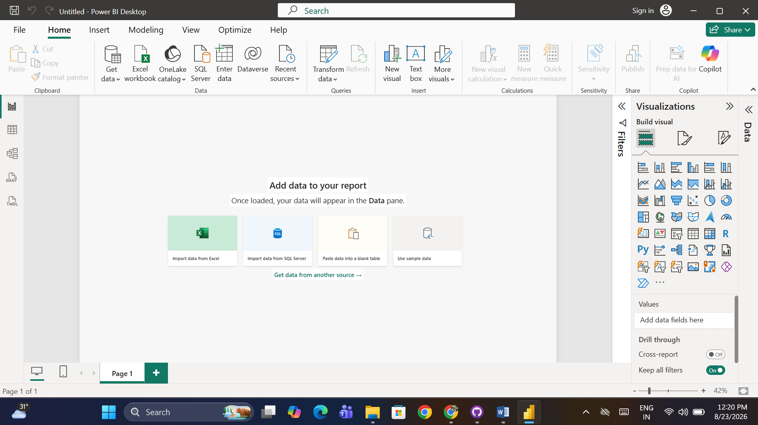

Task 2 - Power BI Desktop interface components
Component | Short description
Report View | The main workspace used to build report pages and add charts, tables, cards, slicers, and other visuals.
Data View | Shows the data loaded into the model in a table-like format. It is useful for inspecting columns and rows before building visuals.
Model View | Displays relationships between tables and helps you create or manage the data model, including relationships and table structure.
Fields Pane | Lists available tables, columns, measures, and other model fields that can be dragged into visuals.
Visualizations Pane | Provides visual types and formatting options. It is used to choose a visual, add fields to it, and format its appearance.
Filters Pane | Used to apply filters at the visual, page, or report level so that only the required data appears.

Task 3 - Create a blank report, add a table visual, and rename the page
Required page name: My First Dashboard
1. Open Power BI Desktop and create a new blank report.
2. On the report canvas, select the Table visual from the Visualizations pane.
3. Add fields from the Fields pane to the table visual. For a practice setup, use any available text field and numeric field from the loaded dataset.
4. Right-click the report page tab and choose Rename, then enter My First Dashboard.
5. Confirm that the table visual appears on the page and the page tab is named My First Dashboard.
Table visual representation (for documentation):
Category | Product | Sales
Electronics | Laptop | ₹75,000
Clothing | T-Shirt | ₹1,200
Home | Chair | ₹4,500
Note: The table above is a documentation example, not a live Power BI visual embedded from the application.

Task 4 - Excel Dashboards vs Power BI Dashboards
Area | Excel Dashboard | Power BI Dashboard
Data workflow | Often uses worksheet ranges, formulas, PivotTables, and manual refresh/update steps. | Designed around imported/connected data models, relationships, measures, and refreshable datasets.
Visualization & interaction | Good for spreadsheet-based charts and controls, but interactivity is usually more worksheet-driven. | Provides a wider set of interactive visuals, slicers, cross-filtering, drill-down, and report navigation features.
Data modeling & scale | Can handle substantial analysis, but complex models may become harder to maintain inside a workbook. | Built for structured data modeling with relationships, DAX measures, multiple tables, and larger reporting workflows.
Conclusion: Power BI is especially useful when the goal is an interactive, model-driven dashboard that can combine data sources, relationships, measures, and rich visual interactions. Excel remains very strong for spreadsheet calculations, ad-hoc analysis, and worksheet-based reporting.

